P3Speller Task for BCI2000

Shidong Zheng, Melody Moore, Vaishali Kamat, Gerwin Schalk
July 31, 2006
TABLE OF CONTENTS

1. Introduction 3
2. Visual Representation 4
3. Nested Matrices 5
4. Control of P3Speller Task 10
4.1 Pause and Sleep 10
5. Text Window 10
6. Parameters 11
7. States 15

Introduction

The P3Speller task presented the user with flexible dimension of matrix of characters, where the 6 by 6 matrix is the most common size (see Figure 1). The user’s task was to focus attention on characters in a word that was prescribed by the investigator (i.e., one character at a time). All rows and columns of this matrix were successively and randomly intensified at a rate of 5.7Hz. Two out of 12 intensifications of rows or columns contained the desired character (i.e., one particular row and one particular column). The responses evoked by these infrequent stimuli (i.e., the 2 out of 12 stimuli that did contain the desired character) are different from those evoked by the stimuli that did not contain the desired character and they are similar to the P300 responses.

The entire set of stimuli is usually flashed several times before the P3Speller calculates the desired character. The number of times the set flashes is determined by the ‘NumberOfSequences’ parameter. To ensure maximum efficiency of character prediction, it is important that the stimuli are infrequent even between sequences. Modifications were made to the application so that the row or column that was intensified last in a sequence will not be the first to intensify in the next sequence.

The P3Speller application will catch such responses and then determine the character that user was focused on. After the P3Speller determine the character, it will print the character to the screen (below the word to spell) for the user to verify.

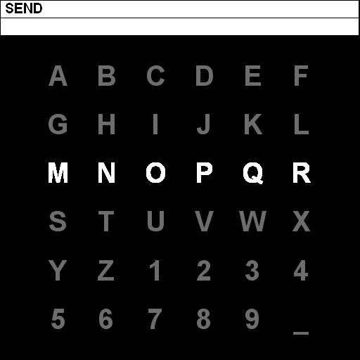

Figure 1: This figure illustrates the 6 by 6 matrix display of P3Speller. In this example, the user’s task is to spell the word “SEND” (one character at a time). For each character, all rows and columns in the matrix were intensified a number of times (e.g., the third row in this example) as described in the text.

Visual Representation

The visual representation of P3Speller is divided into three parts: Text to Spell, Text Result, and Speller Display (Figure 2). Text to Spell is the area that displayed the text that user needs to spell. This area is used when user is doing spelling practice. Text Result is the area where P3Spller printed the user’s input after analyzed the evoked response from the user. Speller Display is the main area where P3Speller application displayed the matrix of characters and randomly intensified them in specified frequency.

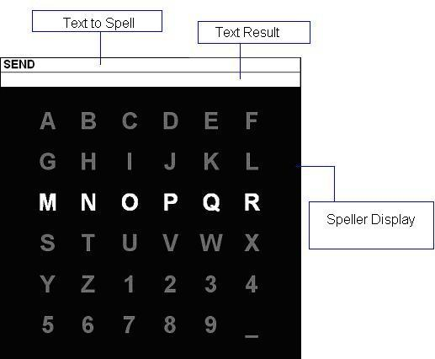

Figure2: This figure illustrates the 6 by 6 matrix display of P3Speller. Usually, user will acknowledge the Text to Speller then watches the Speller Display. The P3Spller application will analyze the evoked response and print the selected text in Text Result.

In addition to the text characters, it is possible to display icons (bitmaps) in the P3Speller matrix. This can be achieved by entering the appropriate file name for the icon in column 4 of the desired cell in the TargetDefinitionMatrix. The icon will be flashed (highlighted) using one of 3 methods, viz GRAYSCALE, INVERT, DARKEN. The method to be used can be selected using a parameter. When the “Darken” method is chosen, a scale factor needs to be input as the ‘HighlightFactor’ parameter.

While in online mode, as the user selected gets displayed in the result area, it is possible that the display width becomes full. At this stage, a character-wise scrolling operation will be initiated, removing the leftmost text from the display to make room for the latest selection by the user.

It is also possible to play a .wav sound file or “speak” text (using a Text-to-Speech engine) when a cell is selected. To play a sound file, the .wav file name should be entered in column 5 of the desired cell in the target definition matrix. To enable a text-to-speech function, the text to be “spoken” should be entered in column 5 of the desired cell in the target definition matrix within single quotes (‘e.g. text’), as shown below.

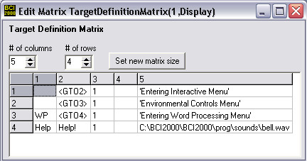

The Text-to-Speech engine uses the default “voice” setting on the PC. This can be set via the Control Panel as follows: Control Panel->Speech->TextToSpeech->Voice Selection. Choices are available for a male or female voice.

Nested Matrices

New capability has been added to enable the P3Speller application to transition through several matrices in a nested manner. For example, the cells in the first matrix would be tied to another matrix which would get displayed if this cell is selected by the user. This capability can be used to design a menu based user interface. To support nested matrix capability, changes have been made so that each cell in the target definition matrix can be defined as a single value or as a sub_matrix.

To use the nested menu capability with P3Speller, the following steps need to be executed:

STEP 1: Setting up TargetDefinitionMatrix

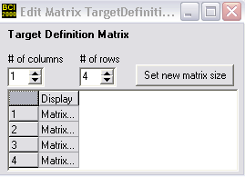
Figure 3: Target Definition matrix for nested menus

To enable nested menu functionality, the TargetDefinitionMatrix must have 1 column and can have as many rows as the number of different menus desired. For example, the TargetDefinitionMatrix shown in Figure 3 configures P3Spller for nested operation with 4 different menus.

To maintain backward compatibility and for ease of configuration, the application will not support nested functionality by simply converting one cell of the ‘old’ target definition matrix to a sub-matrix. To define nested matrices, the parameter TargetDefinitionMatrix must be defined with 1 column and each cell as a sub-matrix. If it has more than one column, the application will treat it as a single matrix and will ensure that each of its cells is defined as a single value.

STEP 2: Convert each cell to a sub-matrix
In the GUI, this is done by right-clicking on any cell as shown in Figure 4.

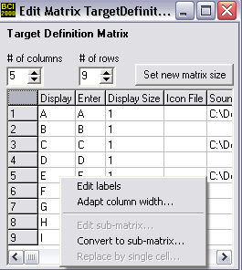

Figure 4: Converting cells to sub-matrix.

STEP 3: Configure individual sub matrices
Each cell of the TargetDefinitionMatrix in a nested matrix is a sub-matrix (as shown in Figure 3) and should be configured individually. In the GUI, clicking on a cell that is a sub-matrix will bring up that matrix in another window, as shown in Figure 5.

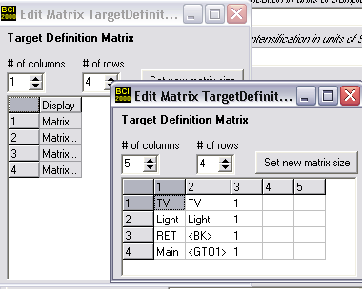
Figure 5: Configuring individual sub-matrices

Each sub-matrix should be configured to have a minimum of 3 columns and can have upto 5 columns if it needs to display icons or play sounds.

STEP 4: Enabling transition from one menu to another
Special characters have been added to support the transition from one matrix to another. The sequence <GTO#> where # is the matrix number (i.e. index in the target definition matrix) should be placed in the “Enter” column of the cell that needs to call menu #. The sequence <BK> will take the system back to the previous menu/ matrix. See Figure 5.

STEP 5: Number of Rows and Columns of each nested menu (matrix)
The number of rows and columns that each sub-matrix has needs to be recorded in the NumMatrixRows and NumMatrixColumns parameters. The individual entries are separated by a SPACE.

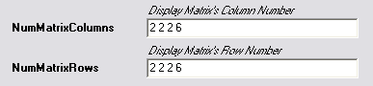
Figure 6: Rows and Columns of each sub-matrix

Figure 6 indicates that the first three sub-matrices are 2x2, while the sub-matrix at index 4 is a 6x6 matrix.

In case of a traditional (non-nested) TargetDefinitionMatrix, there will be only one entry in the NumMatrixRows and NumMatrixColumns parameters.

STEP 6: Select first menu to be displayed

A parameter has been added to allow selection of the first menu to be displayed when the application is run. The index of the menu to be displayed first (i.e. when the application is started) should be entered in the parameter FirstActiveMenu. In case of the traditional non-nested matrix configuration, this parameter should be left at its default value of 1.

The overall representation of a nested matrix configuration is shown in Figure 7 below.

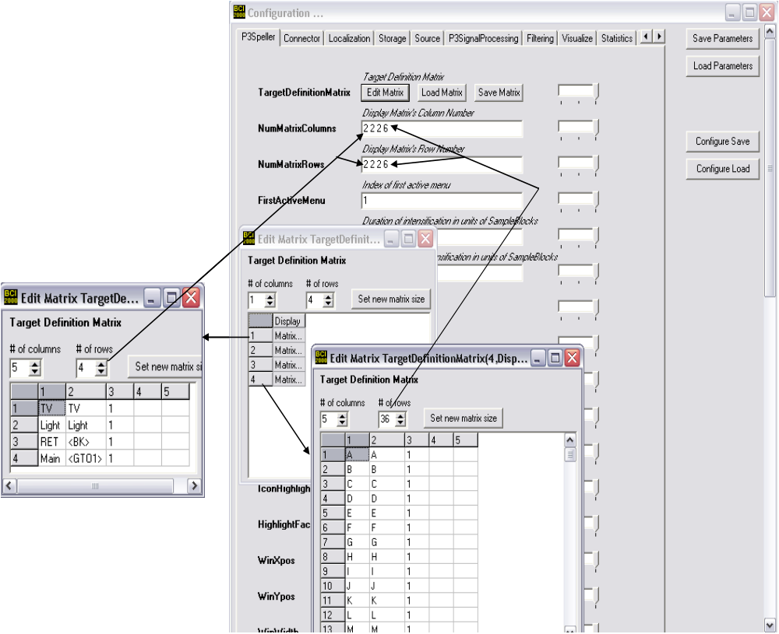

Figure 7: Nested matrix Configuration

Control of P3Speller Task

P3Spller can be controlled in two input mode. First mode is the test mode. Under test mode, user can select the target character through mouse click during each of the flashing trail. P3Speller then will recognize the mouse click and print the clicked character in the Result Text part. Second mode is the normal mode, where P3Speller will acquire user’s EEG signal through electro cap. P3Speller then analyze the signal through appropriate BCI2000 signal processing module to determine which character did the user focus attention to during the flashes. P3Speller then print the targets character to the Result Text. Whether to use the mouse click or user’s EEG signal to determine targeted character is define by a parameter value.

Pause and Sleep

Two special characters have been added to enable the user to stop the P3Speller either momentarily or for an extended period of time.

The <PAUSE> special character pauses the P3Speller task. While the system is paused, the matrix will continue to flash but target selections shall be ignored until the user restarts the system, which is achieved by selecting the <PAUSE> character again. Data recording (to the log file) shall also be suspended while the system is paused. The “goal text” line of the status bar will indicate that the system is paused. Note that for a matrix with n stimuli, the system will automatically select the <PAUSE> cell and thus restart itself within n trials.

The <SLEEP> special character can be used to stop the P3Speller for a longer period of time. It has been designed such that once in sleep state, the system will restart only after receiving two consecutive <SLEEP> selections. This will prevent automatic restart within n trials as in the case of the pause state. The “goal text” line of the status bar will indicate that the system is in sleep mode and will instruct the user to select the “Sleep” cell twice to restart.

Note that <PAUSE> and <SLEEP> are special characters and should be inserted in the “Enter” column of the desired cell in the target definition matrix.

Text Window

The capability to display user selected text in a text window is available. This feature can be activated by selecting the TextWindowEnabled parameter. The text window can be enabled only in online (free spelling) mode. The position and size of the window as well as display font can be configured via appropriate parameters.

When the text window is enabled, any text that the user selects will appear in the text window, in addition to the text result area of the P3Speller display. The text window will scroll automatically.

Two special keys are available to perform Save and Retrieve operations on the text window. When the <SAVE> key is selected, the text in the text window will get written to a file and be erased from the window. The file name will be auto generated with the date and time stamp. The directory to which the file gets sent is pre-set as a parameter. The <RETR> (retrieve) function reads the latest file that was saved by the user and recalls the text into the text window.

A separate “clear” key has not been provided in the text window functions to prevent unintentional deletion of its contents. The only way to clear the contents of the text window is using <SAVE>.

Parameters

This section describes the parameters that configure the P3Speller task. The parameters are grouped by the section they belong to, i.e., the tab in the Operator’s configuration menu they appear in.

Section P3SignalProcessing

- NumERPsToAverage: Number of ERPs to average before doing DF.

- NumSamplesInERP: Number of samples stored for each response.

- TargetERPChannel: Target Channel for ERP Display in order of SignalProcessing transfer.

Section P3Speller

- BackgroundColor: The background color of the Speller Display, it is defaulted to black.

- DestinationIPAddress: If this parameter is not empty, the P3Speller sends its output (i.e., the selected character or word (i.e., the entry in the first column of the TargetDefinitionMatrix for the selected cell/row)) to a networked client via UDP. This parameter defines both IP address and port number (e.g., localhost:12768, 130.27.3.2:3265). For each selected cell, it sends: P3Speller_Output[SPACE]output[CRLF]

- FirstActiveMenu: Used in nested menu configurations to indicate the index of the menu (matrix) that will be displayed at system start up. For non-nested configurations, this should be left at its default value of 1.

- HighlightFactor: Applies only when IconHighlight is set to “DARKEN”. This number controls the amount by which the intensity of the icon is reduced.

- IconHighlight: Provides 3 choices for the method to be used for highlighting icons, viz. GRAYSCALE, INVERT, DARKEN.

- NumberOfSequences: Number of sets of 12 intensifications.

- NumMatrixColumns: The number of columns of the speller matrix character. This parameter can take the form of a vector incase of nested menu configuration. The number of columns in each menu should be entered here separated by a SPACE.

- NumMatrixRows: The number of rows of the speller matrix character. This parameter can take the form of a vector incase of nested menu configuration. The number of rows in each menu should be entered here separated by a SPACE.

- OffTime: Intervals between intensifications in units of SampleBlocks.

- OnlineMode: If the online mode check box is selected, the P3Speller’s text to spell box will be empty. If the check box is not selected, the P3Speller will show a practice mode, where the text to spell box will show the text in the Text to Spell parameter.

- OnTime: Duration of intensification in units of SampleBlocks.

- P3TestMode: When the test mode is on, user can choose the character by using the mouse to click on the character on the speller display. When the test mode is off, user can only input through the EEG signal.

- PostSetInterval: Duration after set of intensifications in units of SampleBlocks.

- PreSetInterval: Duration before set of n intensifications in unites of SampleBlocks.

- ResultDisplay: If the ResultDisplay box is selected, it will show the input from the user on the Text Result box.

- StatusBarSize: Total size of the Text to Spell and Text Result box in percentage of the screen height.

- StatusBarTextHeight: Size of the text in Text to Spell and Text Result box in percentage of screen height.

- TargetDefinitionMatrix: The matrix parameter that defined the character display, character definition, and character size in the Speller Display. The number of characters must be equal to the product of the rows and the columns in the Speller Display. Two new columns have been added to the matrix to store file names for the icons to be displayed and the sound to be played for each cell. It is optional to fill in values for these columns but the matrix is required to have 5 columns as shown below.

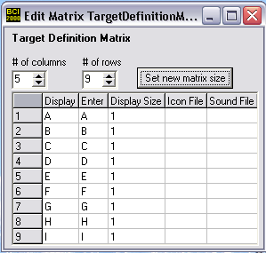
Figure 8: Columns in target definition matrix.

The columns in the target definition matrix are as follows (See Figure 8):

    - Display – contains the character(s) to be displayed on the screen in the matrix
    - Enter – contains the character(s) that get put in the result string when the cell is selected.
    - Display Size – is the scale factor for the on screen display
    - Icon file – is the full path name of the bitmap file to be displayed in this cell
    - Sound file – is the full path name of the .wav file to be played or the text to be spoken when this cell is selected.

Several special characters are available to perform certain functions like back space, end etc. The special characters should be put in the “Enter” column of the appropriate cell of target definition matrix. The special characters supported are:

- <BS> - Backspace: Deletes one character from the result string (and text window).
- <DW> - Delete Word: Deletes the last word from the result string (and text window).
- <END> - Stops the program
- <SAVE> - Saves contents of the text window into a text file. This special character is valid only when the text window is enabled.
- <RETR> - Retrieves the last text file that was saved by the <SAVE> function into the text window. This special character is valid only when the text window is enabled.
- <GTO#> - Used only in nested menu configurations. Transitions to menu (matrix) #.
- <BK> - Used only in nested menu configurations. Returns to previous menu.
- <PAUSE> - Pauses the P3Speller temporarily until the character is selected again.
- <SLEEP> - Puts the P3Speller in sleep mode when selected once and returns to normal operation when selected again two consecutive times.

- TargetHeight: Height of the character in the Speller Display in percents of screen height.

- TargetWidth: Width of the character in the Speller Display in percents of screen width.

- TextColor: Color of the text character in the Speller Display.

- TextColorIntensified: Color of the text character in the Speller Display when they are intensified.

- TextResult: User spelled result text.

- TextToSpell: Characters of string to spell when online mode check box is unchecked.

- TextWindowEnabled: Boolean control to enable and disable the text window.

- TextWindowFilePath: The directory path in which the text window files will be saved. The complete path needs to be entered here.

- TextWinFontName: The name of the font for the text in the text window.

- TextWinFontSize: The size of the font for the text in the text window.

- TextWinHeight: The height of the text window in pixels.

- TextWinWidth: The width of the text window in pixels.

- TextWinXpos: The X position of the text window on the screen in pixels.

- TextWinYPos: The Y position of the text window on the screen in pixels.

- WinHeight: The window height of the P3Speller display in pixels.

- WinWidth: The window width of the P3Spller display in pixels.

- WinXpos: The window X position of the P3Speller display on the screen in pixels.

- WinYpos: The window Y position of the P3Speller display on the screen in pixels.

States

The time line of stimulus delivery is encoded in state variables as defined in Table 1.

State Name | Bits | Description
Stimulus Code | 5
Stimulus Type | 3
Running | 1 | 1: system is running, 0: system is suspended
Flashing | 1
PhaseInSequence | 2
SelectedTarget | 7 | Selected target’s ID
SelectedRow | 3 | Selected row number in the Speller Display
SelectedColumn | 3 | Selected column number in the Speller Display
StimulusCodeRes
StimulusTypeRes
StimulusTime | 16 | 16-bit unsigned integer; resolution 1 ms
Nested |  | 1: Nested matrix configuration 0: single matrix

Table 1: Encoding scheme for this task.

